Cauchy-Binet formula | (Theorem)

Let be an 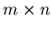matrix and an 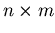matrix. Then the determinant of their product can be written as a sum of products of minors of and :
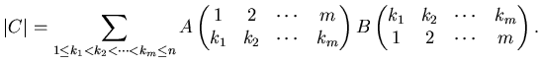
Basically, the sum is over the maximal (-th order) minors of and . See the entry on minors for notation.
If 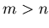, then neither nor have minors of rank , so 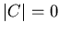. If , this formula reduces to the usual multiplicativity of determinants 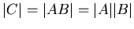.
Proof. Since , we can write its elements as 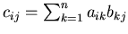. Then its determinant is
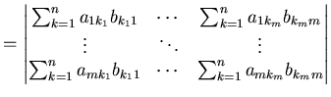
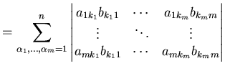
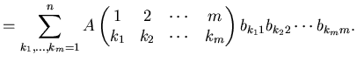
In both steps above, we have used the property that the determinant is multilinear in the colums of a matrix.
Note that the terms in the last sum with any two 's the same will make the minor of vanish. And, for 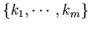's that differ only by a permutation, the minor of will simply change sign according to the parity of the permutation. Hence the determinant of can be rewritten as
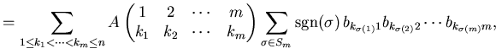
where is the permutation group on elements. But the last sum is none other than the determinant 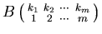. Hence we write
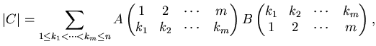
which is the Cauchy-Binet formula.

